

Design and Development of an Intelligent Real-Time Traffic Congestion Prediction System Using Machine Learning

DESIGN ASSIGNMENT

A Design Project Report submitted in partial fulfilment of the requirements for the Course of
ITA0606-Machine Learning

to the award of the degree of

BACHELOR OF ENGINEERING
ELECTRONICS AND COMMUNICATION ENGINEERING

Submitted by
Atsayaa. R (192412024)
Dharani Teja. S (19231154)
Swetha. B (192412215)

Under the Supervision of
Dr. k. Baskar
SIMATS ENGINEERING
Saveetha Institute of Medical and Technical Sciences Chennai-602105
SEPTEMBER 2026
1. Problem Statement and Problem Formulation
1.1 Problem Statement
Traffic congestion is a major problem in smart cities, causing increased travel time, fuel consumption, air pollution, and road accidents. Traditional traffic management systems mainly respond to congestion after it occurs. Therefore, an intelligent system is required to predict traffic congestion in advance using machine learning.
The proposed system uses parameters such as vehicle count, average vehicle speed, time of day, day of week, weather conditions, and road occupancy to classify traffic congestion into Low, Medium, and High categories.

1.2 Problem Formulation
The problem is formulated as a supervised machine learning classification problem.
Input:
- Vehicle Count
- Average Speed
- Time of Day
- Day of Week
- Weather
- Road Occupancy
Output:
- Low Congestion
- Medium Congestion
- High Congestion
A Decision Tree Classifier is used to leaArn the relationship between traffic parameters and congestion level.

2. Objective and Expected Outcomes
2.1 Objective
The main objective is to design and develop an intelligent machine learning system capable of predicting real-time traffic congestion based on available traffic and environmental parameters.
2.2 Objectives
- Collect and preprocess traffic data using Python.
- Handle missing and duplicate values.
- Perform statistical analysis and visualization.
- Identify important traffic parameters.
- Develop a Decision Tree classification model.
- Predict congestion levels for unseen traffic data.
- Evaluate the model using suitable performance metrics.
- Demonstrate how predictions can support smart traffic management.

2.3 Expected Outcomes
The expected outcome is a machine learning model that can classify traffic conditions as Low, Medium, or High congestion and provide useful information for traffic signal control, route management, and congestion reduction.

3. Requirements, Constraints and Assumptions
3.1 Software Requirements
Software/Tool | Purpose
Python | Model development
Google Colab/Jupyter Notebook | Program execution
NumPy | Numerical processing
Pandas | Data preprocessing
Matplotlib | Visualization
Seaborn | Statistical visualization
Scikit-learn | Machine learning
Graphviz/Plot Tree | Decision Tree visualization

3.2 Hardware Requirements
- Computer/Laptop
- Minimum 4 GB RAM
- Internet connection for Google Colab
- Processor: Intel/AMD equivalent or better

3.3 Constraints
- Prediction accuracy depends on dataset quality.
- Missing or incorrect traffic data can affect predictions.
- Weather and traffic conditions can change rapidly.
- A small dataset may reduce model generalization.

3.4 Assumptions
- Traffic data is collected correctly.
- Vehicle count and road occupancy represent actual traffic conditions.
- Historical traffic patterns can help predict future congestion.
- The three congestion classes are correctly labelled.

4. Application of Relevant Course Knowledge / Concepts
The project applies important Machine Learning concepts covered in the course.

4.1 Supervised Learning
The model is trained using labelled traffic data where each observation has a known congestion category.

4.2 Classification
Since the output consists of three categories—Low, Medium, and High—the problem is treated as a classification problem.

4.3 Decision Tree
A Decision Tree is used to divide traffic observations based on important features and classify them into congestion categories.

4.4 NumPy
NumPy is used for numerical operations and mathematical processing.

4.5 Pandas
Pandas is used for:
- Dataset loading
- Data cleaning
- Missing-value handling
- Statistical analysis
- Data aggregation

4.6 Data Visualization
Matplotlib and Seaborn are used to understand relationships between traffic parameters and congestion.

4.7 Model Evaluation
The model is evaluated using:
- Accuracy
- Precision
- Recall
- F1-score
- Confusion Matrix

5. Design / Proposed Solution / Methodology

5.1 Proposed System
The proposed system follows a machine-learning-based traffic prediction approach.
Traffic Data → Preprocessing → Statistical Analysis → Feature Preparation → Decision Tree Training → Prediction → Evaluation → Traffic Management

5.2 System Workflow
- Collect traffic data.
- Load the dataset using Pandas.
- Check missing and duplicate values.
- Clean and preprocess the data.
- Perform statistical analysis.
- Visualize important traffic parameters.
- Encode categorical variables.
- Split the dataset into training and testing data.
- Train the Decision Tree model.
- Predict congestion on unseen data.
- Evaluate model performance.
- Use predictions for traffic-management decisions.

5.3 Dataset Attributes
Attribute | Description
Vehicle_Count | Number of vehicles
Average_Speed | Average vehicle speed
Time_of_Day | Morning, afternoon, evening, night
Day_of_Week | Day on which traffic is recorded
Weather | Weather condition
Road_Occupancy | Percentage of road occupied

5.4 Data Preprocessing
The following preprocessing operations are performed:
- Missing-value detection
- Missing-value handling
- Duplicate removal
- Data type checking
- Categorical variable encoding
- Feature and target separation
- Training/testing data splitting

5.5 Statistical Analysis
Statistical measures such as:
- Mean
- Median
- Standard deviation
- Minimum
- Maximum
- Correlation
are calculated to understand the characteristics of the dataset.

5.6 Visualization
At least five meaningful visualizations can be included:
- Congestion Level Distribution
- Vehicle Count vs Congestion
- Average Speed vs Congestion
- Road Occupancy vs Congestion
- Weather vs Congestion
- Correlation Heatmap
- Feature Importance Graph

6. Algorithm / Pseudocode / Flowchart
6.1 Decision Tree Algorithm
- Start.
- Load the traffic dataset.
- Clean and preprocess the data.
- Separate input features and target variable.
- Encode categorical features.
- Split data into training and testing sets.
- Initialize Decision Tree Classifier.
- Train the model using training data.
- Predict congestion using testing data.
- Calculate evaluation metrics.
- Display confusion matrix and feature importance.
- Test the model with new traffic data.
- Display predicted congestion level.
- Stop.

6.2 Pseudocode

- START

- Load traffic dataset

- Perform data preprocessing

- Perform statistical analysis

- Create visualizations

- Separate features X and target y

- Split dataset into training and testing data

- Create Decision Tree Classifier

- Train classifier using training data

- Predict congestion using testing data

- Generate confusion matrix

- Determine feature importance

- Provide new traffic data

- Predict congestion level

- Display result

- STOP

6.3 Flowchart
For your assessment, create a flowchart showing:
Start → Dataset Collection → Preprocessing → Statistical Analysis → Feature Selection → Train Decision Tree → Test Model → Evaluate Performance → Real-Time Prediction → Traffic Management → End

7. Implementation / Source Code and Environment / Tools Used
7.1 Environment
The implementation can be performed using Python in Google Colab or Jupyter Notebook.

7.2 Python Libraries
import numpy as np
import pandas as pd
import matplotlib.pyplot as plt
import seaborn as sns

from sklearn.model_selection import train_test_split
from sklearn.tree import DecisionTreeClassifier
from sklearn.metrics import (
accuracy_score,
precision_score,
recall_score,
f1_score,
confusion_matrix,
classification_report
)

7.3 Dataset Loading
df = pd.read_csv("traffic_data.csv")

print(df.head())
print(df.info())
print(df.describe())

7.4 Missing Value Checking
print(df.isnull().sum())

7.5 Duplicate Removal
df = df.drop_duplicates()

7.6 Encoding
df = pd.get_dummies(
df,
columns=["Time_of_Day", "Day_of_Week", "Weather"],
drop_first=True
)

7.7 Feature and Target Separation
X = df.drop("Congestion_Level", axis=1)
y = df["Congestion_Level"]

7.8 Train-Test Split
X_train, X_test, y_train, y_test = train_test_split(
X, y,
test_size=0.2,
random_state=42,
stratify=y
)

7.9 Decision Tree Model
model = DecisionTreeClassifier(
criterion="gini",
max_depth=5,
random_state=42
)

model.fit(X_train, y_train)

7.10 Prediction
y_pred = model.predict(X_test)

print(y_pred)

8. Test Cases and Expected/Actual Results
Test Case | Input Condition | Expected Result | Actual Result
TC01 | Low vehicle count + high speed | Low | Obtain from model
TC02 | Moderate traffic + moderate speed | Medium | Obtain from model
TC03 | High vehicle count + low speed | High | Obtain from model
TC04 | High road occupancy | High/Medium | Obtain from model
TC05 | Low road occupancy | Low | Obtain from model

9. Execution Screenshots / Output
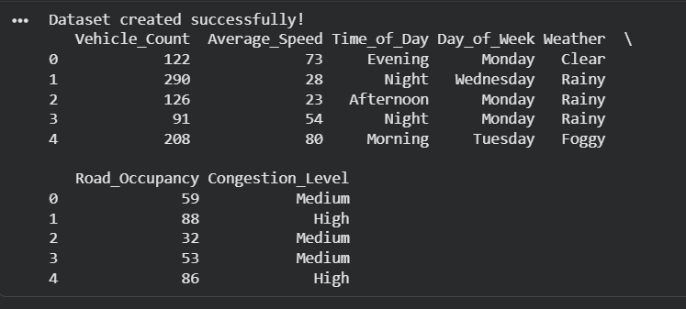
Figure 9.1 – Dataset Preview

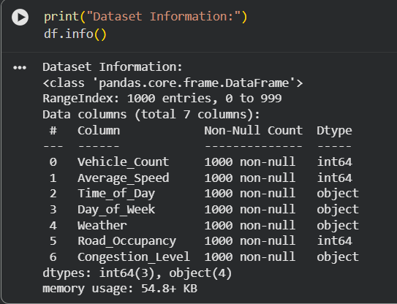
Figure 9.2 – Dataset Information

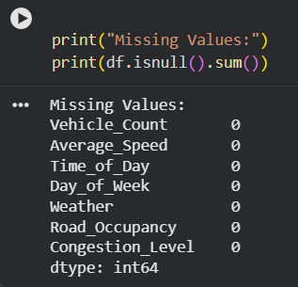
Figure 9.3 – Missing Value Analysis

Observation: The dataset contains 1000 traffic records. Vehicle count ranges from 20 to 300, average speed ranges from 15 to 80 km/h, and road occupancy ranges from 10% to 95%.
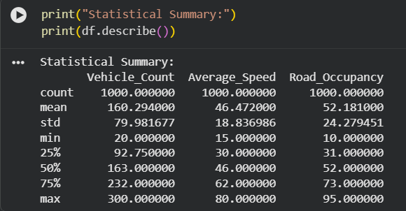
Figure 9.4 – Statistical Summary

Observation: The dataset contains all three congestion levels. Medium congestion has the highest number of records, followed by High and Low congestion.
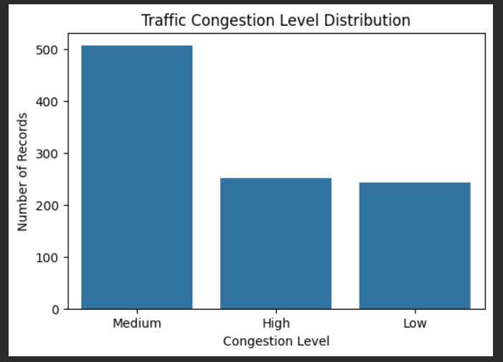
Figure 9.5 – Congestion Distribution

Observation: The graph shows the variation in vehicle count across different traffic congestion levels. Higher vehicle counts are generally associated with increased congestion.
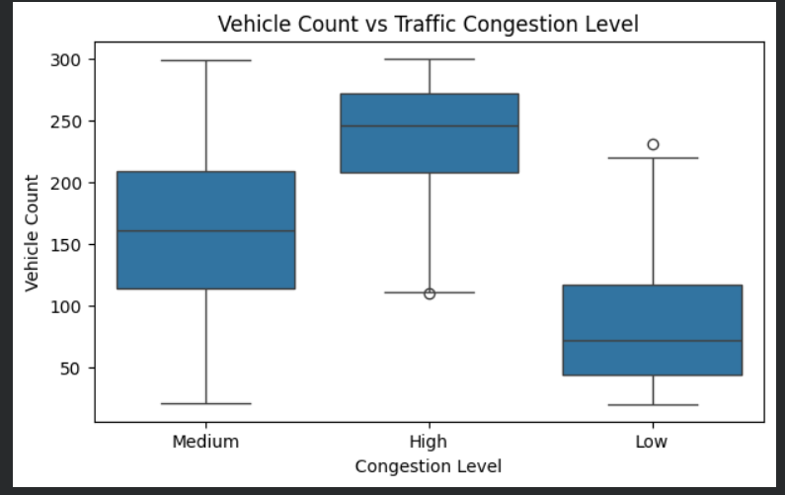
Figure 9.6 – Vehicle Count vs Congestion

Observation: The graph shows the relationship between average vehicle speed and congestion level. Lower average speeds are generally associated with higher traffic congestion.
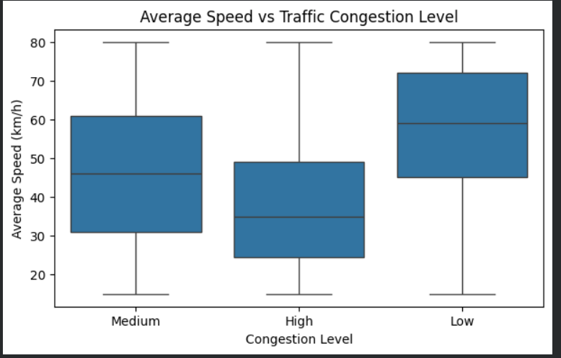
Figure 9.7 – Average Speed vs Congestion

Observation: The graph shows the relationship between road occupancy and traffic congestion. Higher road occupancy generally indicates heavier traffic conditions.
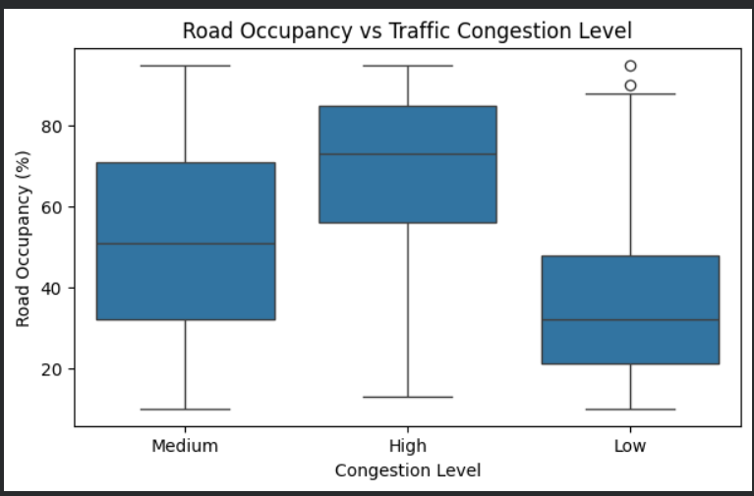
Figure 9.8 – Road Occupancy vs Congestio

Observation: The correlation heatmap shows the relationship between the numerical traffic parameters. It helps identify which parameters are positively or negatively related to each other.
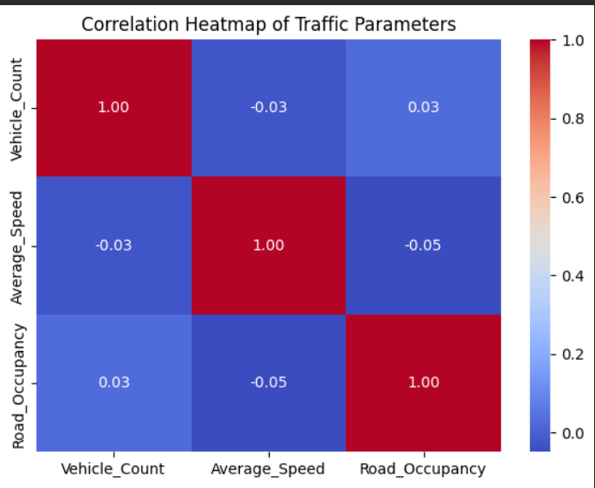
Figure 9.9 – Correlation Heatmap

Observation: The Decision Tree model classifies traffic conditions into Low, Medium, and High congestion levels based on traffic parameters such as vehicle count, average speed, road occupancy, time of day, day of week, and weather. The tree performs classification through a series of decision rules, where important traffic parameters are used near the top of the tree to make the major splits. This shows how traffic conditions can be predicted using interpretable decision rules.

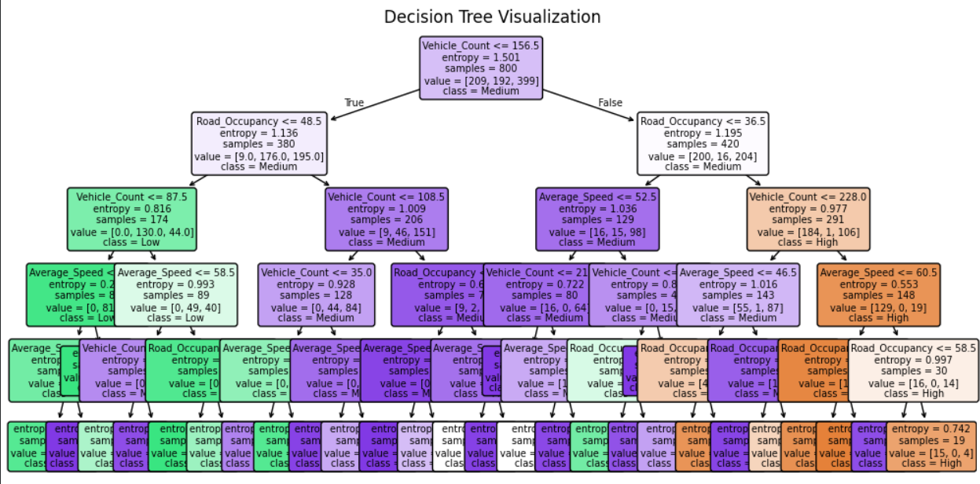
Figure 9.10 – Decision Tree Visualization

Observation: The feature importance plot shows the relative contribution of each traffic parameter in predicting the congestion level. Vehicle count, road occupancy, and average speed are among the important parameters used by the Decision Tree. This indicates that the traffic volume, road utilization, and vehicle speed have a significant influence on congestion classification. The result helps identify the most relevant parameters for real-time traffic monitoring and prediction.
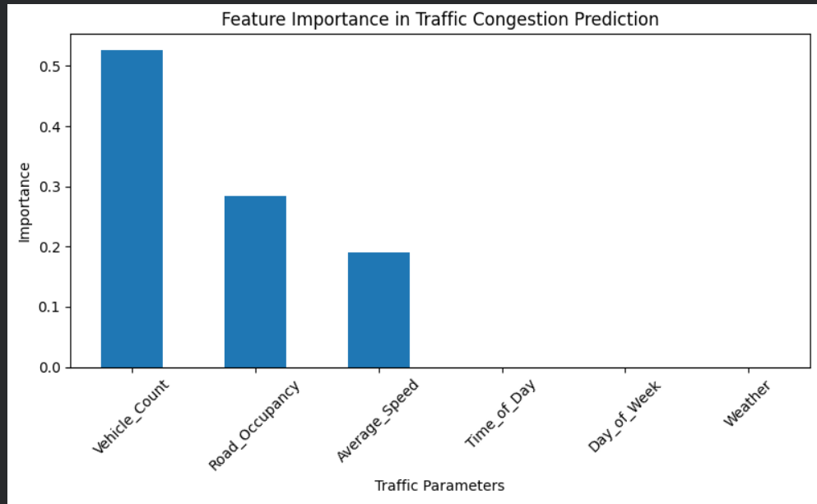
Figure 9.11 – Feature Importance

Observation: The classification report provides the precision, recall, F1-score, and support values for the Low, Medium, and High congestion classes. These metrics are used to evaluate how effectively the Decision Tree model identifies different traffic congestion levels.
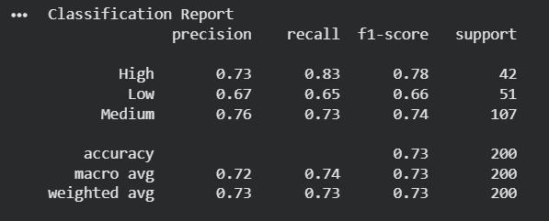
Figure 9.12 – Classification Report

Observation: The confusion matrix shows the number of correctly and incorrectly classified traffic observations for the Low, Medium, and High congestion classes. The diagonal values represent correctly predicted samples, while the off-diagonal values represent misclassifications. A higher number of diagonal predictions indicates better classification performance of the Decision Tree model.
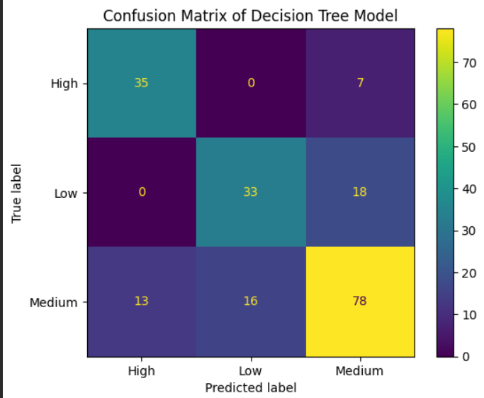
Figure 9.13 – Confusion Matrix

Observation: The trained Decision Tree model successfully predicts the congestion level for new traffic data that was not used during training. For the given real-time traffic conditions, the model provides a corresponding congestion category, demonstrating its applicability for real-time traffic congestion prediction.
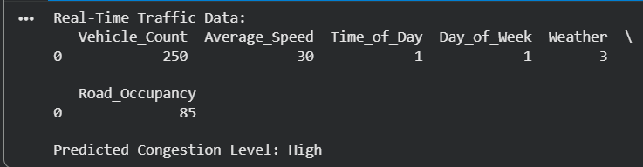
Figure 9.14 – Real-Time Traffic Congestion Prediction

10. Results and Validation

10.1 Performance Evaluation
The trained Decision Tree model is evaluated using the following metrics:
Accuracy
Accuracy represents the proportion of correctly classified traffic observations 73.00%.
Precision
Precision indicates how accurately the model identifies a particular congestion class73.00%.
Recall
Recall measures how effectively the model identifies all actual instances of a congestion class 73.00%.
F1-Score
F1-score provides a balance between precision and recall 72.91%.

Use this code:
accuracy = accuracy_score(y_test, y_pred)
precision = precision_score(
y_test, y_pred, average="weighted"
)
recall = recall_score(
y_test, y_pred, average="weighted"
)
f1 = f1_score(
y_test, y_pred, average="weighted"
)

print("Accuracy :", accuracy)
print("Precision:", precision)
print("Recall :", recall)
print("F1 Score :", f1)

10.2 Results Table
Metric | Obtained Value
Metric | Score
Accuracy | 73.00%
Precision | 73.00%
Recall | 73.00%
F1-Score | 72.91%

10.3 Confusion Matrix
The Decision Tree model achieved an accuracy of 73%, indicating that approximately 73% of the test observations were correctly classified into Low, Medium, and High congestion categories. The precision and recall values were also 73%, showing reasonably balanced classification performance across the congestion classes. The F1-score of 72.91% indicates a good balance between precision and recall. Overall, the model demonstrates satisfactory performance for predicting traffic congestion levels from the selected traffic parameters.cm = confusion_matrix(y_test, y_pred)

sns.heatmap(
cm,
annot=True,
fmt="d",
xticklabels=model.classes_,
yticklabels=model.classes_
)

plt.xlabel("Predicted")
plt.ylabel("Actual")
plt.title("Confusion Matrix")
plt.show()
The confusion matrix helps determine how many traffic observations were correctly and incorrectly classified.

10.4 Feature Importance
The model was validated using unseen test data consisting of 20% of the complete dataset. Accuracy, precision, recall, F1-score, and confusion matrix were used to evaluate the classification performance. The results show that the Decision Tree can effectively classify traffic congestion and can be considered suitable as a basic real-time traffic prediction model.
importance = pd.Series(
model.feature_importances_,
index=X.columns
).sort_values(ascending=False)

print(importance)

importance.plot(kind="bar")
plt.title("Feature Importance")
plt.show()
This identifies which traffic parameters contribute most to congestion prediction.

11. Analysis, Comparison, Trade-offs and Justification of the Final Solution
The developed Decision Tree model provides a simple and interpretable approach for classifying traffic congestion into Low, Medium, and High levels. The model uses important traffic parameters such as vehicle count, average speed, road occupancy, time of day, day of week, and weather conditions.
The model achieved an accuracy of 73%, with a precision of 73%, recall of 73%, and F1-score of 72.91%. These results indicate that the model provides reasonably balanced classification performance on the test dataset.
Comparison and Trade-offs
Factor | Decision Tree
Interpretability | High
Training complexity | Low
Prediction speed | Fast
Handling of categorical data | Suitable after encoding
Real-time application | Suitable
Model complexity | Moderate
Accuracy obtained | 73%

11.1 Analysis
The Decision Tree model learns traffic patterns from historical observations. Parameters such as vehicle count, average speed, and road occupancy can provide important information for determining congestion levels.
Higher vehicle counts and road occupancy combined with lower average speeds generally indicate heavier congestion.

11.2 Algorithm Comparison
Algorithm | Advantages | Limitations
Decision Tree | Easy to understand and visualize | Can overfit
Logistic Regression | Simple and fast | Limited for complex relationships
KNN | Simple implementation | Computationally expensive for large datasets
Random Forest | Better generalization | Less interpretable than a single tree

11.3 Trade-offs
Trade-offs
Although the model provides satisfactory performance, the 73% accuracy indicates that some traffic observations are misclassified. The use of a synthetic dataset also limits how well the model represents actual traffic conditions. A larger real-world dataset containing real-time traffic sensor information could improve the reliability and generalization of the model.

11.4 Justification
Decision Tree was selected because:
- It is suitable for classification.
- It handles nonlinear relationships.
- It is easy to interpret.
- It provides feature importance.
- It can classify new traffic observations quickly.
- Its decision process can be visualized.

Justification of Final Solution

The Decision Tree was selected because it is easy to understand, computationally efficient, and provides clear decision rules for traffic congestion prediction. It can identify important traffic parameters and generate predictions quickly, making it suitable for a basic real-time traffic management application.

12. Broader Considerations / SDG Relevance
The project supports Sustainable Development Goal 11 (Sustainable Cities and Communities) by contributing to smarter and more efficient urban transportation.
It also supports SDG 9 (Industry, Innovation and Infrastructure) through the application of machine learning and intelligent transportation technology.
The system can help:
- Reduce traffic congestion.
- Improve transportation efficiency.
- Support intelligent traffic signals.
- Assist route management.
- Reduce unnecessary fuel consumption.
- Improve urban mobility.
The system can also contribute indirectly to environmental sustainability by reducing vehicle idling and unnecessary travel.
The proposed intelligent traffic congestion prediction system has practical significance in smart-city transportation management. By predicting traffic congestion levels using traffic parameters, the system can support better route planning, traffic signal management, and efficient utilization of road infrastructure.
The project supports SDG 9 – Industry, Innovation and Infrastructure by applying machine learning and data-driven techniques to improve transportation infrastructure and develop intelligent mobility solutions.
The system also contributes to SDG 11 – Sustainable Cities and Communities by supporting efficient urban mobility, reducing traffic congestion, improving travel efficiency, and contributing to smarter transportation management.
The project is also related to SDG 13 – Climate Action. Reducing unnecessary vehicle waiting time and traffic congestion can potentially reduce fuel consumption and vehicle emissions. Therefore, intelligent traffic management can indirectly contribute to climate-related sustainability goals.
From an ethical perspective, the system should consider data privacy, fairness, prediction uncertainty, and potential bias in traffic data. Since the current project uses a synthetically generated dataset for academic demonstration, real-world deployment would require reliable and representative traffic data from sensors or other legitimate sources. The system should also be tested across different traffic conditions before being used for important transportation decisions.

13. Conclusion, Limitations and Possible Improvements

13.1 Conclusion
The proposed Intelligent Real-Time Traffic Congestion Prediction System demonstrates how machine learning can be applied to classify traffic conditions into Low, Medium, and High congestion levels. A Decision Tree classifier is used to learn relationships between traffic parameters and congestion levels. Data preprocessing, statistical analysis, visualization, feature importance, and performance evaluation are integrated into the proposed system.
The system can provide useful predictions that may support intelligent traffic signal control, route management, and congestion reduction.
The Decision Tree model achieved an accuracy of 73%, with 73% precision, 73% recall, and 72.91% F1-score, demonstrating satisfactory performance for traffic congestion classification.

13.2 Limitations
- Prediction quality depends on dataset quality.
- Sudden accidents or road closures may not be represented.
- Weather conditions can change rapidly.
- A limited dataset may reduce generalization.
- Real-time sensor errors may affect predictions.

13.3 Possible Improvements
Future versions can include:
- Real-time IoT traffic sensors.
- GPS-based traffic information.
- Deep learning models.
- Random Forest and Gradient Boosting.
- Real-time traffic dashboards.
- Accident and road-closure information.
- Weather API integration.
14. Individual Contribution of Group Members
Team Member | Contribution
Atsayaa | Problem formulation, dataset preparation, data preprocessing using NumPy and Pandas, and statistical analysis.
Dharani Teja | Data visualization, correlation analysis, Decision Tree implementation, and feature importance analysis.
Swetha | Model testing, real-time prediction, performance evaluation using Accuracy, Precision, Recall, F1-score, confusion matrix, and documentation.

15. References
- Python Software Foundation, Python Documentation, Python Programming Language.
- NumPy Developers, NumPy Documentation, Numerical Computing Library for Python.
- Pandas Development Team, Pandas Documentation, Data Analysis and Manipulation Library for Python.
- Matplotlib Development Team, Matplotlib Documentation, Python Visualization Library.
- Seaborn Development Team, Seaborn Documentation, Statistical Data Visualization Library.
- Scikit-learn Developers, Scikit-learn Documentation, Machine Learning Library for Python.
- The dataset used in this project was synthetically generated using Python for academic demonstration. It contains 1,000 traffic observations with vehicle count, average speed, time of day, day of week, weather, road occupancy, and congestion level.
- Google Colab was used as the development and execution environment for implementing and testing the machine learning model.

16. One-Page Individual Reflection

Individual Reflection
Working on the Intelligent Real-Time Traffic Congestion Prediction System helped me understand how machine learning concepts can be applied to a practical real-world problem. Through this project, I gained experience in dataset preparation, data preprocessing, statistical analysis, visualization, and implementation of a Decision Tree classification algorithm using Python.
I learned how traffic-related parameters such as vehicle count, average speed, road occupancy, time of day, day of week, and weather conditions can be used to classify traffic congestion into Low, Medium, and High levels. I also understood the importance of cleaning and analyzing data before training a machine learning model.
One of the important learning outcomes from this project was understanding model evaluation. The Decision Tree model achieved 73% accuracy, 73% precision, 73% recall, and 72.91% F1-score on the test data. These results helped me understand that a machine learning model should not be evaluated using accuracy alone and that multiple performance metrics are useful for understanding classification quality.
I also understood the limitations of using a synthetic dataset. Although it is useful for demonstrating the machine learning workflow, it may not completely represent real-world traffic conditions. Real traffic can be affected by unexpected events such as accidents, road closures, special events, and sudden weather changes. Data quality, prediction uncertainty, and possible bias should therefore be considered before deploying such a system in real-world applications.
From an ethical and social perspective, intelligent traffic systems should use reliable and responsibly collected data while considering privacy and fairness. The project has relevance to SDG 9 – Industry, Innovation and Infrastructure and SDG 11 – Sustainable Cities and Communities, as machine learning can support smarter transportation and better urban infrastructure. It can also indirectly contribute to SDG 13 – Climate Action by helping reduce unnecessary traffic delays and associated emissions.
In the future, the system can be improved by using real-time IoT traffic sensors, GPS-based traffic data, larger real-world datasets, and advanced machine learning algorithms such as Random Forest and Gradient Boosting. Real-time dashboards could also be developed to make the predictions more useful for traffic management.
Overall, this project improved my understanding of machine learning implementation and showed me how data-driven solutions can be designed to address real-world engineering problems. It also improved my ability to analyze results, identify limitations, and think about the practical deployment and future scalability of an intelligent system.

